The models should be build in 2 constructions: 1) as now with longrun with weekly and analysed at the start 2) daily datasets – all data in daily form - main analysis.
Again analyse the results and model how it works and match with the tasks and goals of Charniuk_Maksym_MScThesis_Draft_correctedformat.docx. Make the models reliable. Data description of each dataset precise, informative, but not overwhelming, typical for masterthesis in KSE. Check if price transmission is estimated properly – if not – correct it. Show all results with significance for all models outputs in tables in chapters 6.2, 6.3, 6.4 and 6.5 (one table per each). Each model has its output results with values, significantce, CI, etc. – it should shown in tables, or when it I not shown – mentioned in the sentences. Only for key results – the once that are significant, or their insignificance effects conclusions in product or global level (in separate paragrpahs it can be user for proof for information and to move the thoughts=sentences to the next steps)
You must not mention that this is second rerun , or what is improved – you are rewriting chapt 5 and chapter 6 of Charniuk_Maksym_MScThesis_Draft_correctedformat.docx for the current analysis results. So do include what is relevant from it – use exactly the same formatting (you still do not).
The analysis in estimation results and data:
5.1 Final data sources description
5.2 Reconstruction logic, external benchmarks, and transformation choices
5.3 Retail harmonisation, discount logic, and downstream endpoint construction
5.4 Admissibility rules, dataset intersections, and readiness for estimation
Chapter 6. Estimation results, model reliability, and economic interpretation
6.1 Model strategy, diagnostics, and reliability of the retained evidence, long-run affect estimation
6.2 Upstream-to-downstream transmission and the pairwise weekly models
6.3 Downstream extensions, retail behavior, discounts, and procurement scale
6.4 VECM system evidence, aggregate dairy indices, and the limits of full-chain modelling
6.5 Interpretation of the key results, limitations and ways for improvement (widening of this research) for better academical impact
6.0 Conclusion
Concerning the retail+consumer combined - delete it. Get rid of retail+consumer in the model at all, the modeling of retail level should mainly focus on novus+silpo dataset – using price as price_current in silpo (it is price including discounts) and novus price (that price does not have discounts), but also model silpo and novus separately to compare, generate figures too, analyse and decide if it is needed in the Chapter 5 and Chapter 6.
All models are run on daily data mainly – option1) as now is just needed for comparison and start of analysis. The main modeling is on level of product on retail, procurement, producer, and while farm-gate will have only Raw milk price as only 1 price.
If you use formulas – they should be in proper formula box , not like this!! 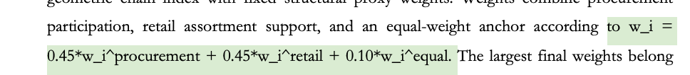
When you work with visulisations – each separate graph should have its own axis labels, not like this , and also they must not have empty period on the graphs – so adapt the period of axis ,like here with procuremet product lines and retail+consumer product lines. Do the visulaisations properly.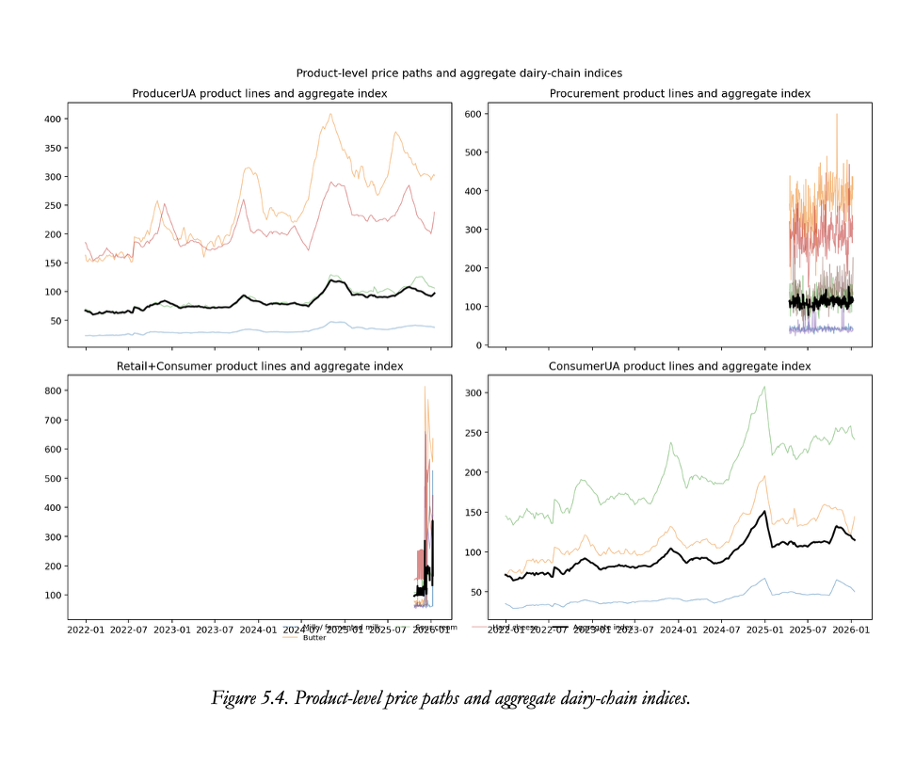
aggregate dairy indices is separate part in 6.4, but it is not main model, it is additional model, which used only in VECM, and compared to the main results.
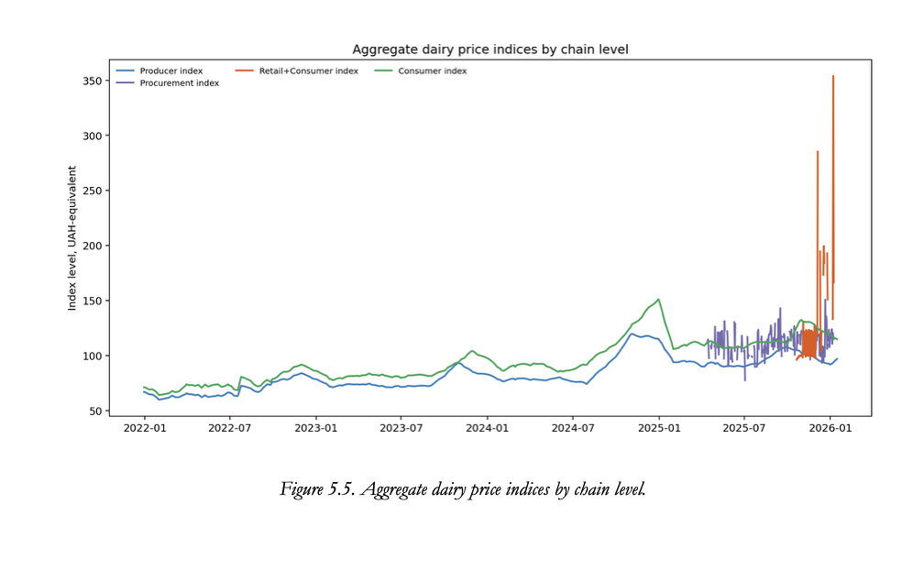such figures like 5.5 should be zoomed to the 2025 and not include retail+consumer, but retail and consumer separately.
Descriptions and interpretation of results should be detailed and explicit, sentences should be academically writte, but not too short exressing thoughts consequently and precisely with argumentation and intepreation. In the same time be laconic, mention all information needed, but do not list a lot of numbers in the same list (more than 3).
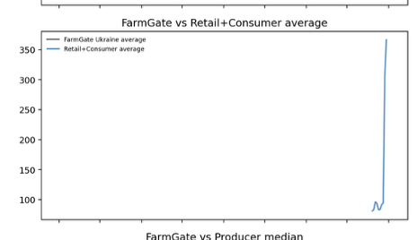such visualization should not exist – first of all – no information, secondly, - second line is not visible or absent – then this graphs is not needed – pick the figures more properly
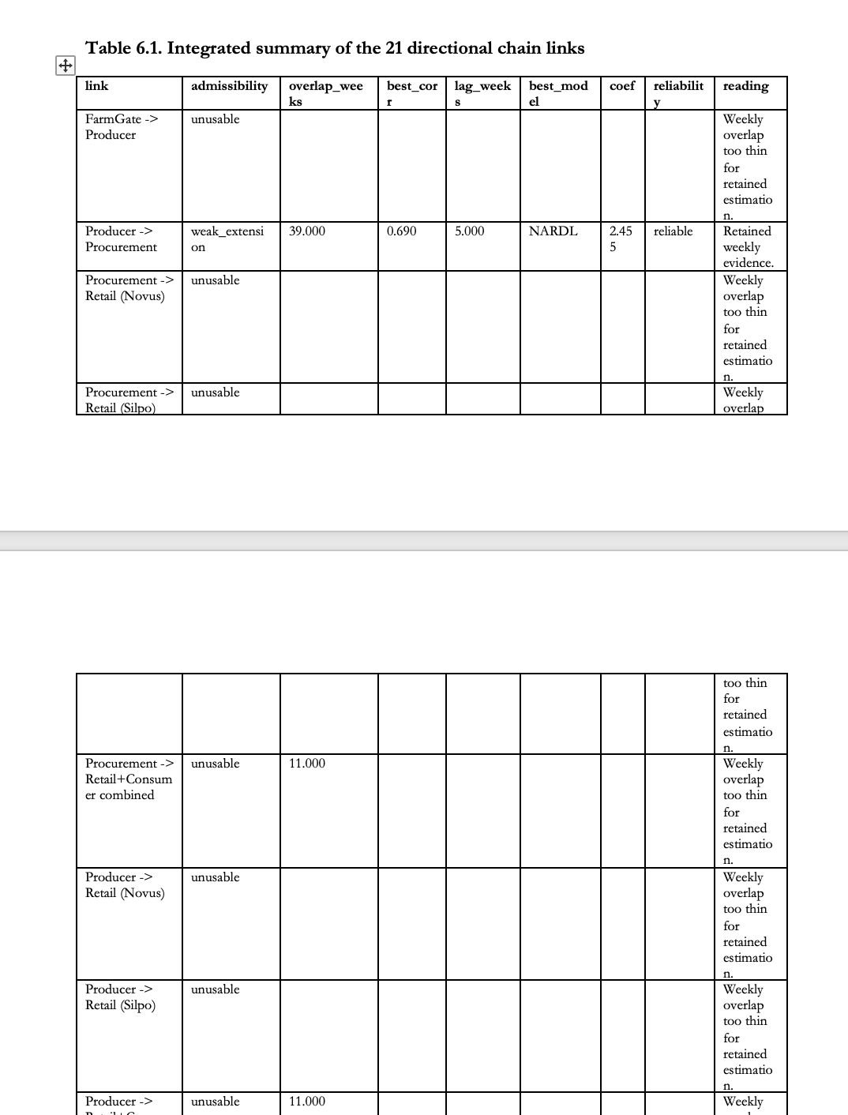tables are off too – there is not enough data.
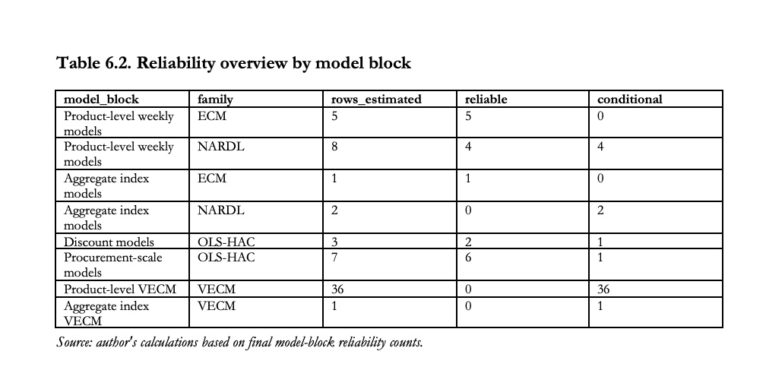such tables are not needed – they must be informative, reliable and show the values of models outputs with all coeficients, etc.
For data in novus+silpo show product distribution and brand disbution, coloring differently silo and novus. Same for regions on procurement (and wherever regional level exists too).

